|  |  |  |
| --- | --- | --- |
| Web Design. | March 7  2016 | |
| **Simple Programs:** | | Unit: ICAWEB502A |

Peter Petersen – 4101833111  
17 Indigo Crescent - Annandale  
Townsville 4814.  
Mobile-0451919894

Input: Create Dynamic Web Pages.

Contents

Task 1 - Setup and test the development environment 4

Organize access to a web server. 5

Create a test web page and load it onto the server 5

Task 2 - write a report on the development environment 6

Write a report on the development environment. 6

Task 3 - Develop dynamic website content 10

Task 4 - Test the website and write a test report 21

Re-validate your pages 21

Resolution: 21

The test procedures used. 27

Usability Testing 28

Figure 1 Google Chrome 5

Figure 2 Firefox 6

Figure 3 Dreamweaver CC 2015 7

Figure 4 USBWebserver 7

Figure 5 Xampp 8

Figure 6 PHPMyAdmin 8

Figure 7 Firefox icon Figure 8 Google Chrome Icon Figure 9 Internet Explorer Icon Figure 10 Adobe Photoshop Icon 8

Figure 11 Sublime Text Editor 9

Figure 12 Folder Structure 9

Figure 13 Mailing list option 10

Figure 14 Mail list successfully added. 11

Figure 15 Mailing List JavaScript Code 12

Figure 16 Administrator Log In 13

Figure 17 Administrators Panel 13

Figure 18 Removed user from mailling list 14

Figure 19 Admin Panel JavaScript 14

Figure 20 Flipping Left Logo 16

Figure 21 Left Logo Returned 16

Figure 22 JavaScript for Flipping Logo 16

Figure 23 Dynamic Background Changes 17

Figure 24 Background Change2 17

Figure 25 Background Change3 17

Figure 26 Background Change 4 17

Figure 27 Dynamic Script for BG Changes 18

Figure 28 Time of day background changes 19

Figure 29 Script for background changes 20

Figure 30 Validation Outputs 21

Figure 31 Screen shots of individual web pages 25

Figure 32 Folder structure used 28

|  |  |  |  |  |  |  |  |  |  |
| --- | --- | --- | --- | --- | --- | --- | --- | --- | --- |
| **Student Name:** | | | Peter Petersen | | | **Student Number:** | | | 4101833111 |
| **Unit Code/s & Name/s:** | | | ICAWEB502A: Create Dynamic Web Pages | | | | | | |
| **Assessment Description:** | | | Practical Assessment | | | | | | |
| **Assessment Due Date:** | | |  | | **Assessment Received Date:** | | |  | |
| **Student Declaration:** I declare that this assessment is my own work. Any ideas and comments made by other people have been acknowledged as references. I understand that if this statement is found to be false, it will be regarded as misconduct and will be subject to disciplinary action as outlined in the TAFE Queensland Student Rules. I understand that emailing or submitting this assessment electronically confirms my assent to this declaration in lieu of a written signature. | | | | | | | | | |
| **Student Signature:** | |  | | | | **Date: 9 / 03 / 2016** | | | |
| **Assessor Feedback:**  **Student provided with feedback** | | | | | | | | | |
| **Attempt 1 Satisfactory  Not Satisfactory  Date:      /     /** | | | | | | | | | |
| **Attempt 2 Satisfactory  Not Satisfactory  Date:      /     /** | | | | | | | | | |
| **Assessor Name:** |  | | | **Assessor Signature:** | | |  | | |
| **Note to assessor: Please record any adjustment below that has occurred to this assessment e.g. Oral questions were used to support student’s ability to complete tasks identified.** | | | | | | | | | |
|  | | | | | | | | | |
| **Disclaimer:** TAFE Queensland North (TQN) is collecting the information on this form for assessment purposes. Only authorised Departmental officers have access to this information. Your personal information will not be disclosed to any other third party without your consent, unless authorised or required by law, in accordance with the Information Privacy Act 2009. | | | | | | | | | |

**This section must be completed by the student when the student either posts or hands a completed assessment/assignment to customer service centres. a receipt is only issued for face to face assessments when requested by the student.**

✀ **RECEIPT**

|  |  |  |  |
| --- | --- | --- | --- |
| STUDENT TO COMPLETE | |  | OFFICE USE ONLY |
| Unit of competency code/s:__________________ | |  |  |
| Assessment item/No: ______________________ | |  | Date received: / / |
| Student’s name: __________________________ | |  |  |
| **Instructions to Student:** | **Time allowed:** This assessment is to be completed over the semester.  **Materials and equipment to be supplied by the Student:**   * Access to a PC, Web Authoring Tools, web server and hosting.   **General Instructions:**   * You will need access to the AllStyles Design Brief * You have 4 tasks to complete. * You will need to answer **all** questions correctly * Keep a copy of all assessments as you will be required, to submit them as a zipped file to your teacher.   NOTE: If you are not successful on your first attempt, you will be given comments and a further two weeks to rectify the changes.  You will need to re-submit your corrections for remarking. If you are unsuccessful on your second attempt, you will be required to re-enrol in this unit. | | |
| **Instructions to Assessor:** | Please see Instructions to Student above. | | |
| **Assessment Context and Description: (if required)** | In order to gain competency in ICAWEB502A: Create Dynamic Web Pages, successful completion is required of the following assessments items:   * Practical Assessment | | |
| **Note to Student:** | An Assessment Matrix is available from your teacher upon request. The matrix shows how the knowledge and skills that you are being asked to demonstrate align to the Elements, Performance Criteria, Critical Aspects, Required Skills and Required Knowledge components of each Unit of Competency. | | |

**Project**

You should create a new folder called '**complex_dynamic_webpages** and save all files in this folder. You should create sub folders as necessary.

The website must display designs, a description of the designs and photographs. Customers should be provided with the ability to complete and email and order form and add their details to a mailing list.

## Task 1 - Setup and test the development environment

You are required to setup and test the development environment. You should document the following and include this in your report:

### Organize access to a web server.

Because I didn’t have access to a physical webserver in class the only option was to use a Virtual software program which was loaded onto a Windows based workstation and used in conjunction with Xampp.

Xampp stands for Cross-Platform (X), Apache (A), MariaDB (M), PHP (P) and Pearl (P); it is a simple, lightweight Apache distribution that makes it extremely easy for developers to create a local web server for testing purposes

Create a test web page and load it onto the server - Create a screen dump of this page.

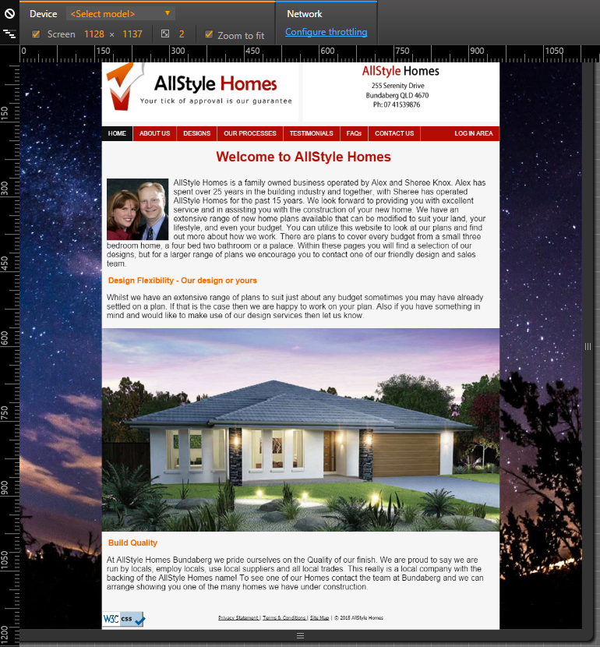

Figure 1 Google Chrome

Figure 2 Firefox

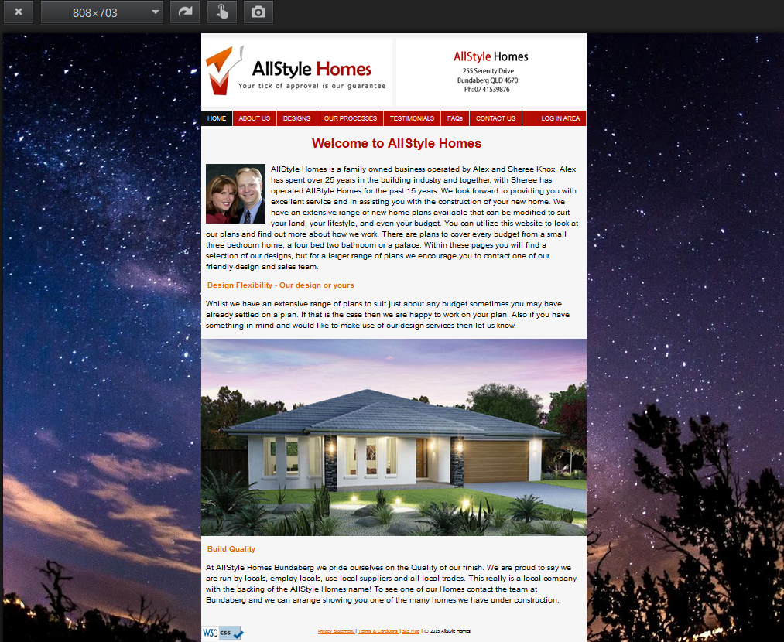

## Task 2 - write a report on the development environment

You are required to write a report detailing the requirements for the development environment. You should:

Write a report on the development environment.   
The report should include: A description of the hardware and software used in the development environment

The hardware used during the development stages of the website were as follows.

**Hardware:**

* Desktop Workstations.
* MSI Laptop.
* Keyboard and mouse.

**Software:**

* Adobe Dreamweaver Creative Cloud 2015.
* USB*Webserver* V8.6
* Xampp V 3.2.2
* PHPMyAdmin
* Mozilla Firefox Browser
* Google Chrome Browser
* Internet Explorer Browser
* Adobe Photoshop
* Sublime Text Editor

Figure 3 Dreamweaver CC 2015

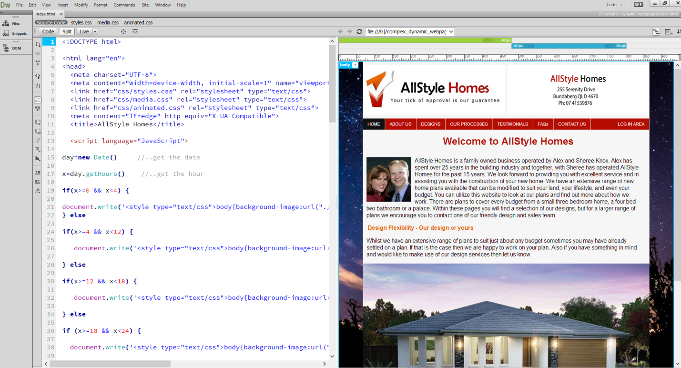

Figure 4 USBWebserver

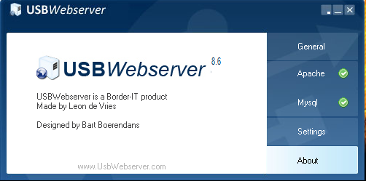

Figure 5 Xampp

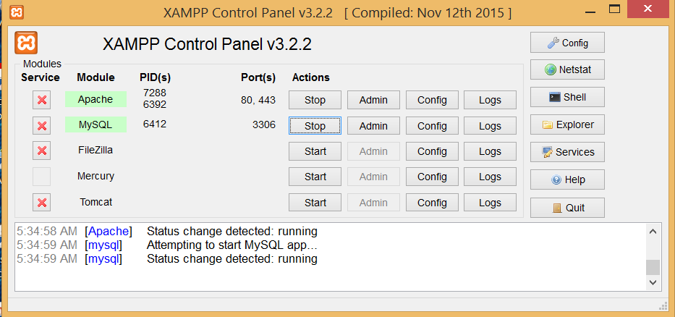

Figure 6 PHPMyAdmin

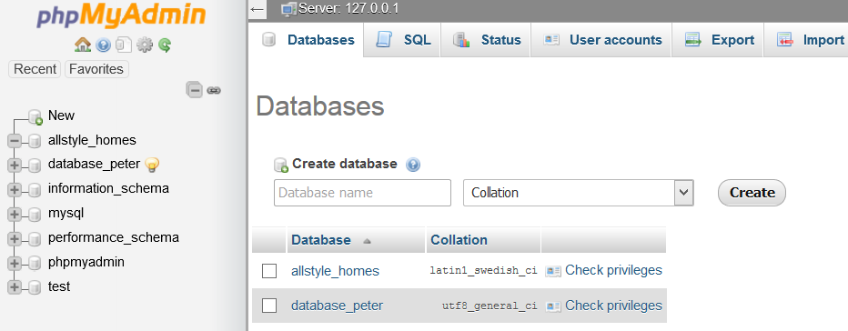

Figure 7 Firefox icon Figure 8 Google Chrome Icon Figure 9 Internet Explorer Icon Figure 10 Adobe Photoshop Icon









Figure 11 Sublime Text Editor

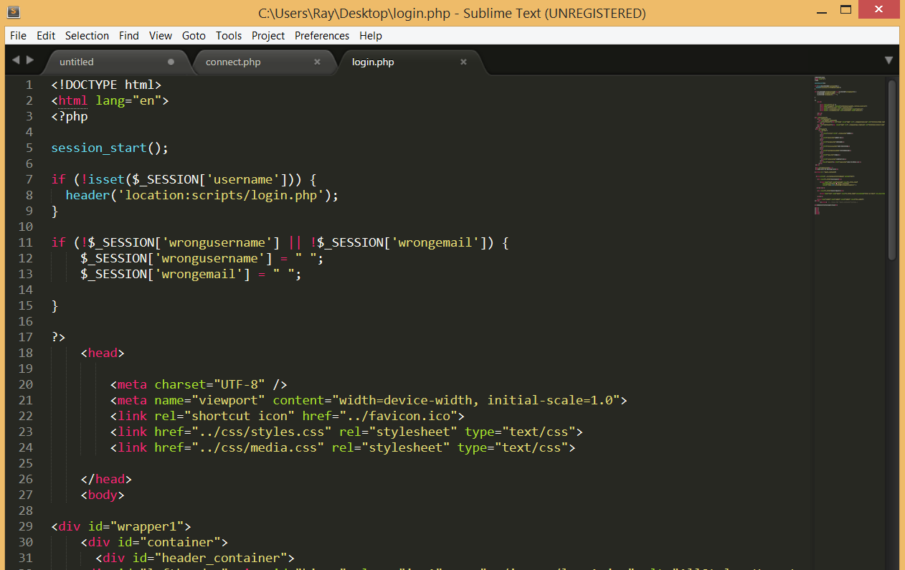

Describe who would be required to have access to the web server and why.

A Network Administrator should have access to all network resources including servers to maintain connectivity and access.  
A staff member should be appointed the task of maintaining the website and will require the need to access the server and database to make amendments to relevant table structures as required.   
A proposed folder structure for your website

Figure 12 Folder Structure

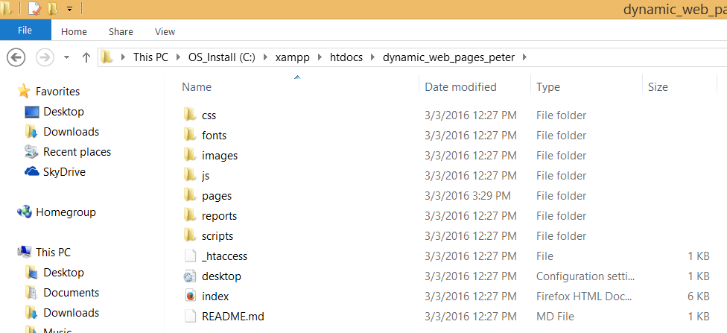

### Task 3 - Develop dynamic website content

In the last topic you began development of a site for a client. For this task you are required to develop some dynamic elements for the site. You will need to document and include this in your report. You should develop dynamic content as follows:

* Ensure that you include:
  + Facility for customers to add their name to a mailing list. You must include code to validate the fields of the form. This code must include:
    - Variables and arrays
    - Functions which use arguments
    - String functions
    - Conditionals (if/else statements)

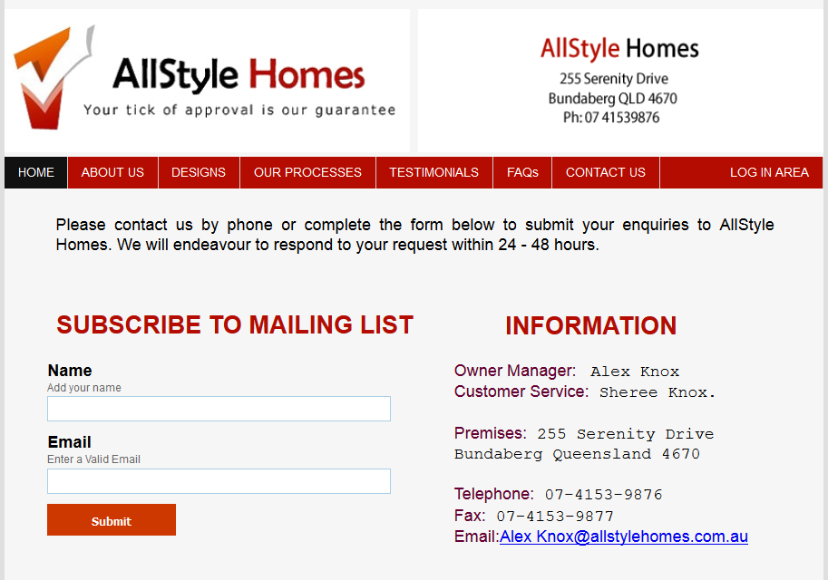

Figure 13 Mailing list option

Figure 14 Mail list successfully added.

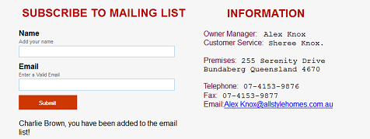

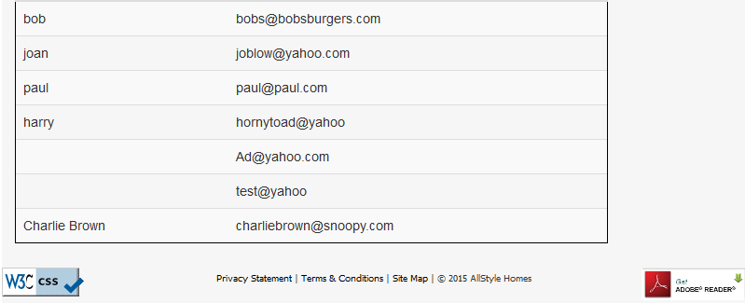

Figure Mailing List JavaScript Code

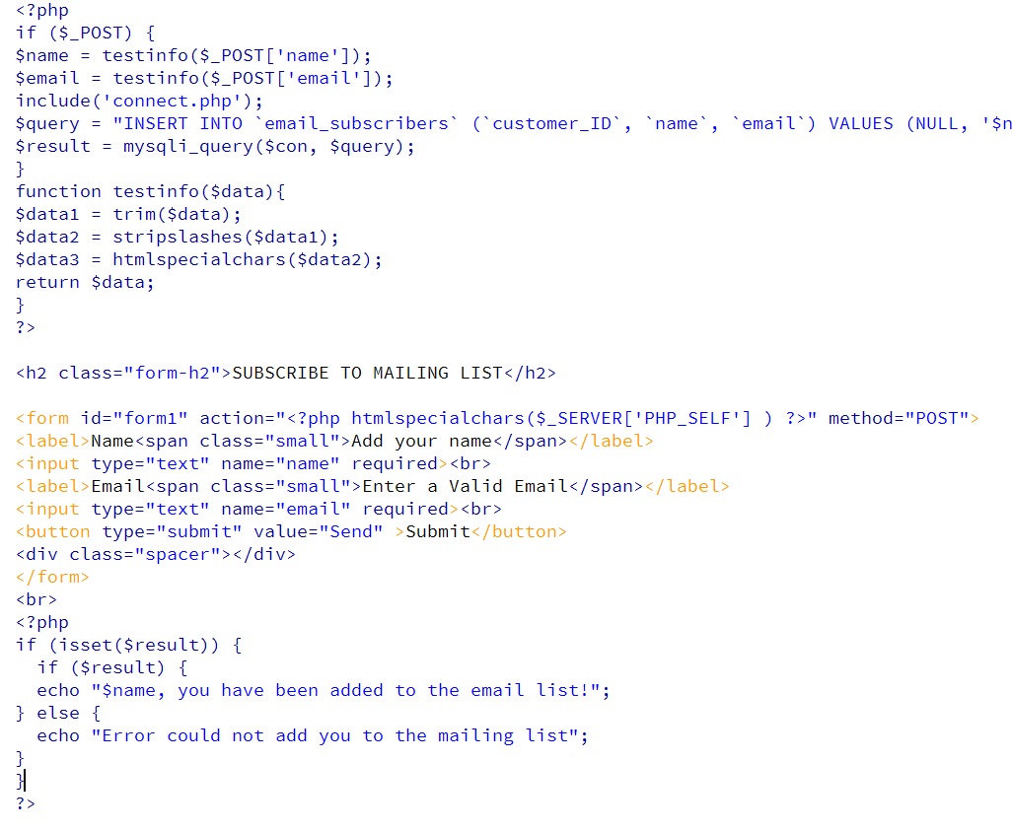

* Facility for administrator to login, and retrieve mailing list for follow up and to delete users.

Figure 16 Administrator Log In

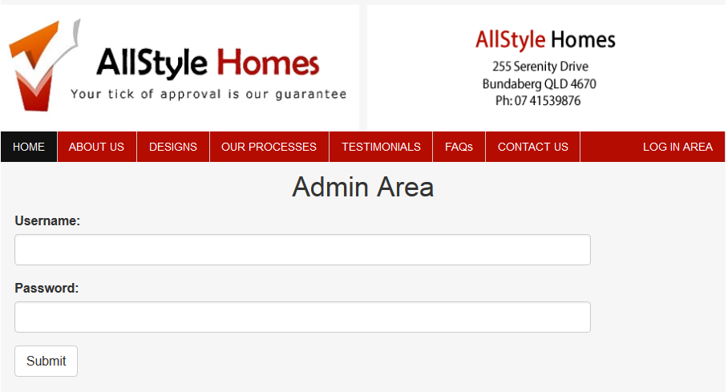

Successful Login

Figure 17 Administrators Panel

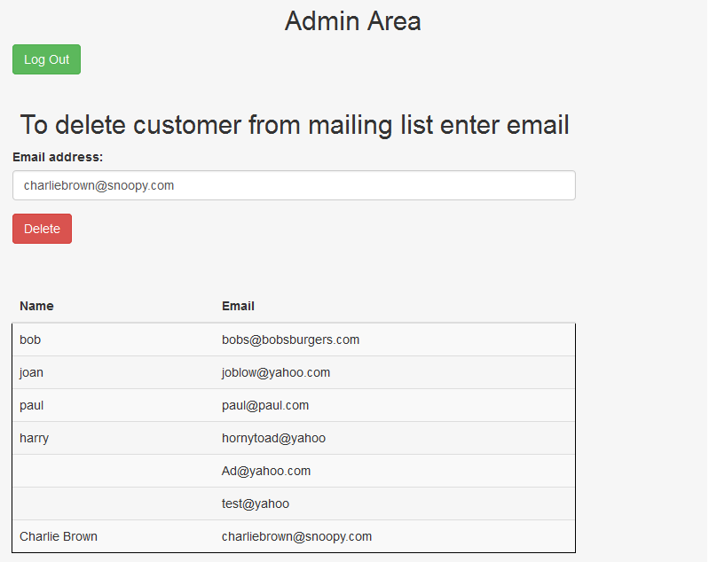

Figure 18 Removed user from mailling list

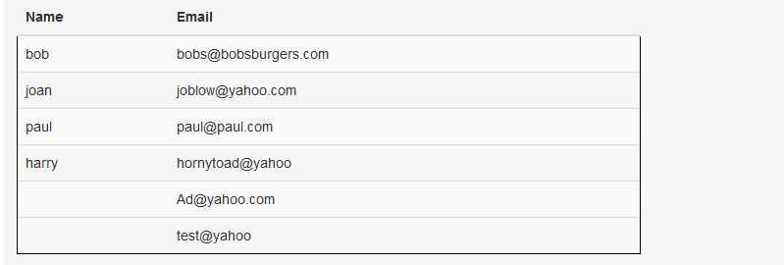

Figure 19 Admin Panel JavaScript

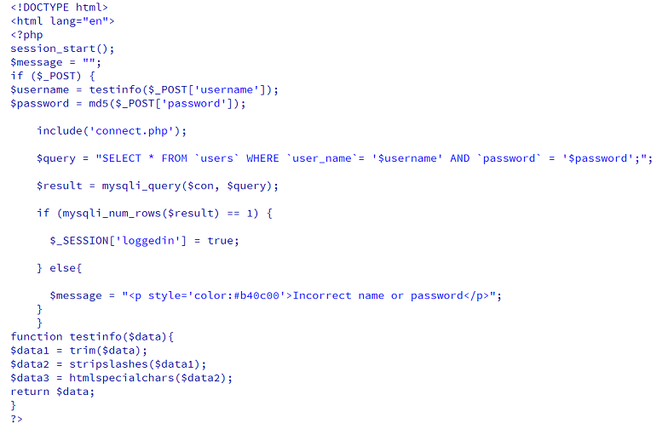

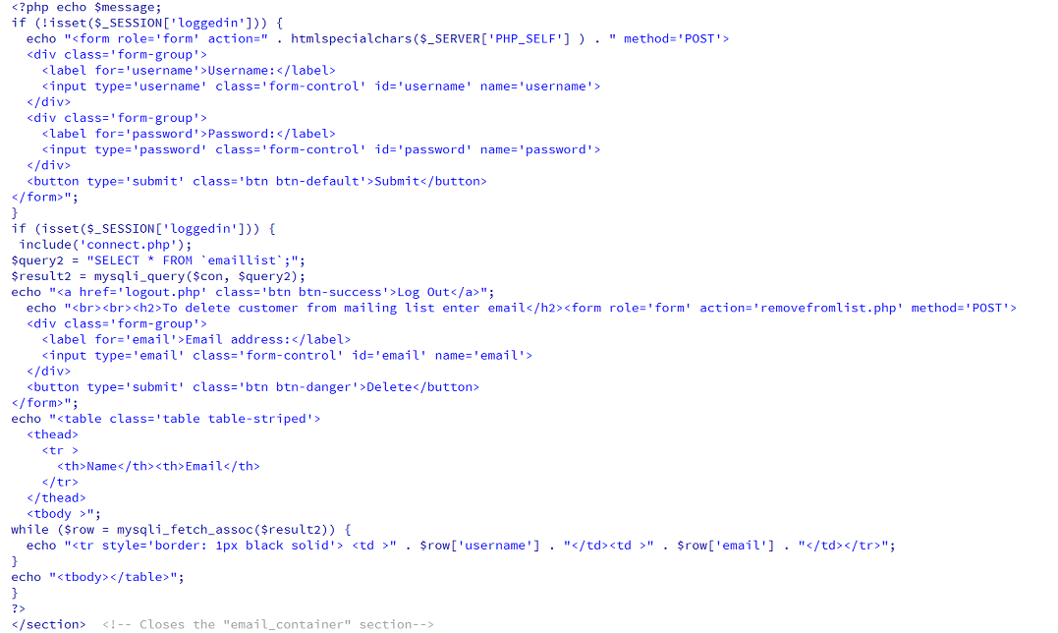

* You must include two (2) dynamic contents in your website. This can include any of the features that you have learnt. For example scrolling text or animation.

Rotating / Animated Flip of image on click command of the mouse.

Figure 20 Flipping Left Logo



Figure 21 Left Logo Returned



Figure 22 JavaScript for Flipping Logo

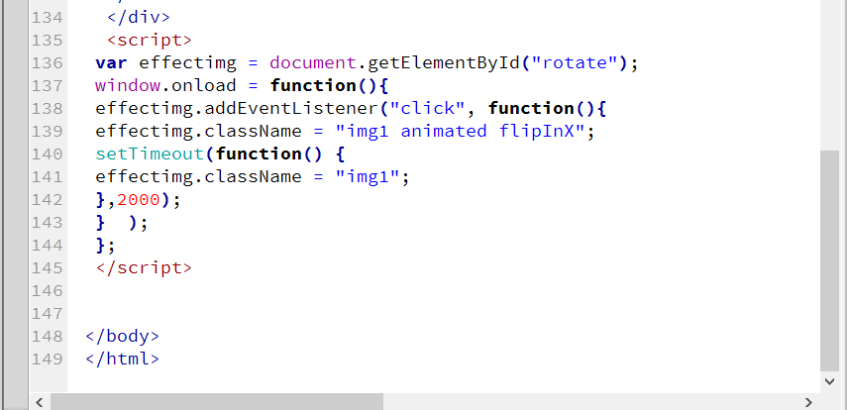

Dynamic Background changes every 5 seconds selected randomly.

Figure 23 Dynamic Background Changes

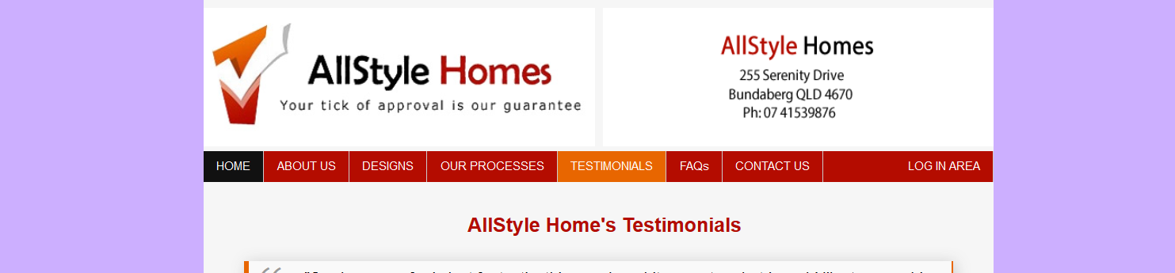

Figure 24 Background Change2



Figure 25 Background Change3



Figure 26 Background Change 4

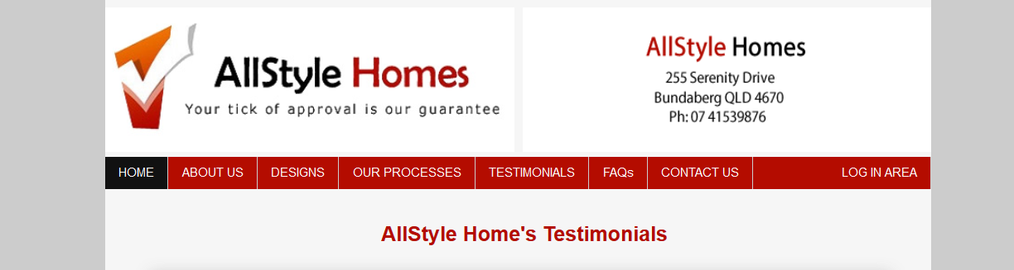

Figure 27 Dynamic Script for BG Changes

The script below selects a random background color, from the color value list.

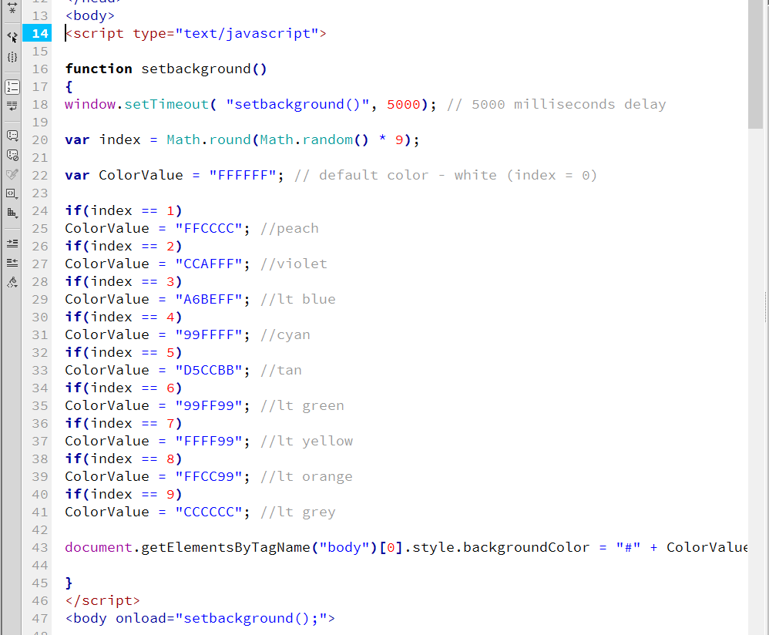

* Develop the site (using JavaScript or some other method) to determine the time of day and change the CSS to display a night time viewing style.

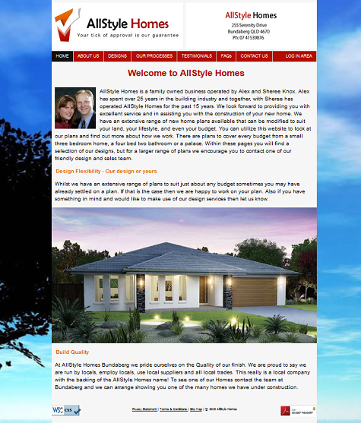 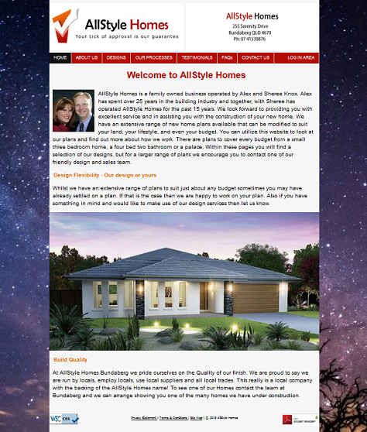

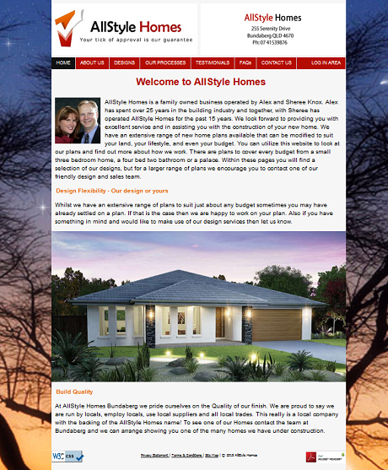 

Figure 28 Time of day background changes

Figure 29 Script for background changes

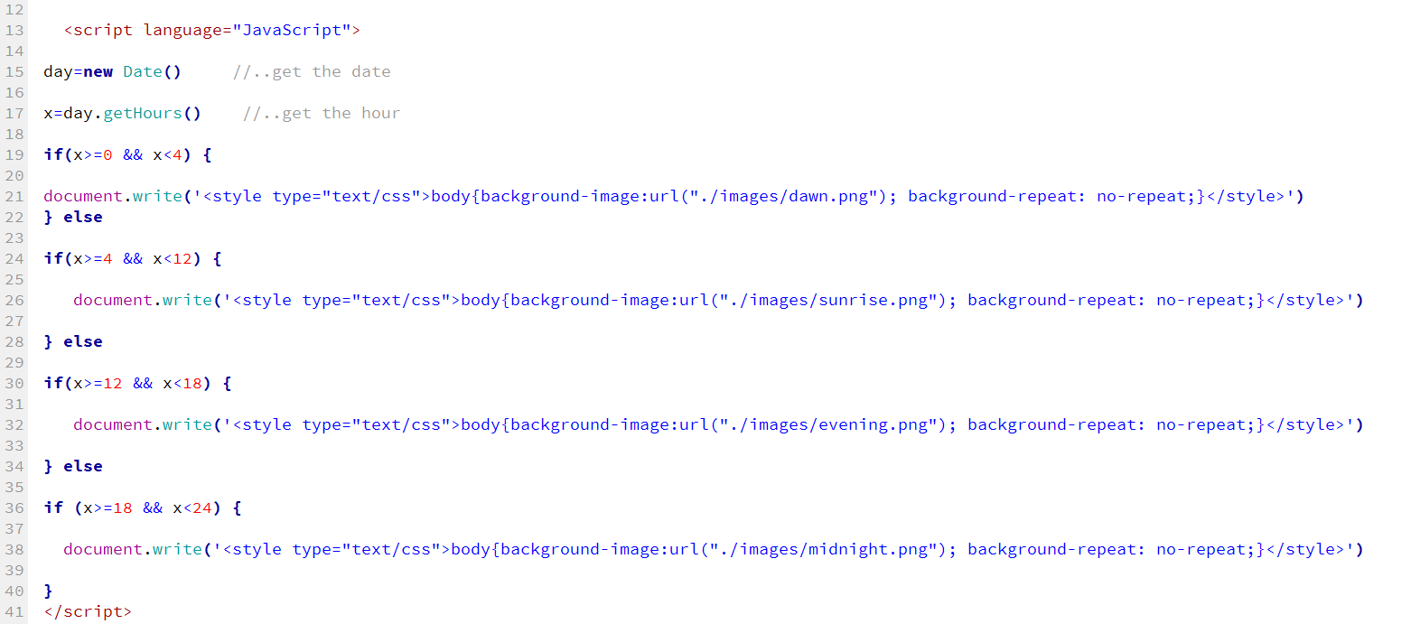

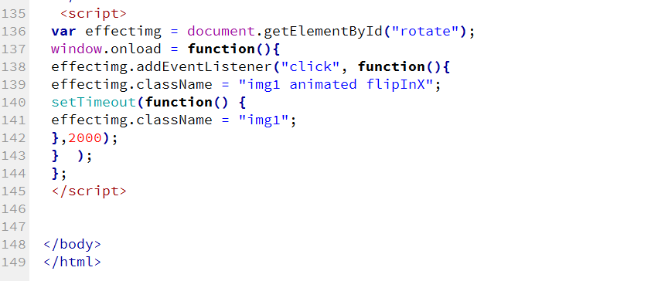

## Task 4 - Test the website and write a test report

You are required to test your website in the development environment and write a brief test report. You should:

Re-validate your pages

Figure 30 Validation Outputs

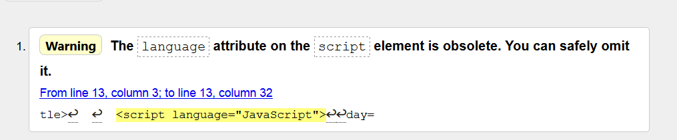

### Resolution:

If I omitted the error code the JavaScript coding would not have rendered on the page, meaning the background transitions would not be operable.   
By replacing the <script language=”JavaScript”> to <script type="text/JavaScript"> Errors have been omitted and a true validation returned.

  
About.html validation

 Designs.html validation



Processes.html validation



Testamonials.html validation

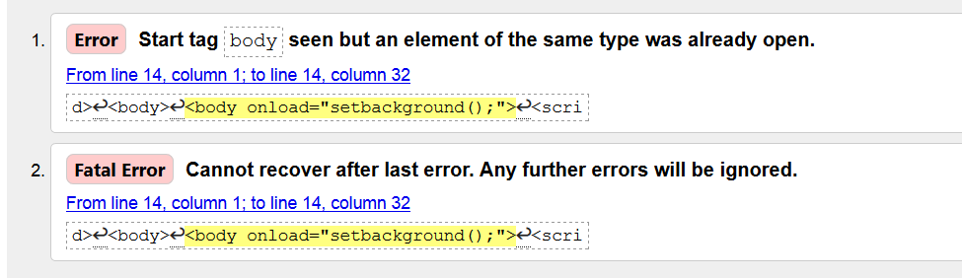

Validator W3.org does not recognize all JavaScript coding; in saying this above error does not affect the performance, loading or the websites page. No action taken.

Faqs.html validation



Contact.php validation

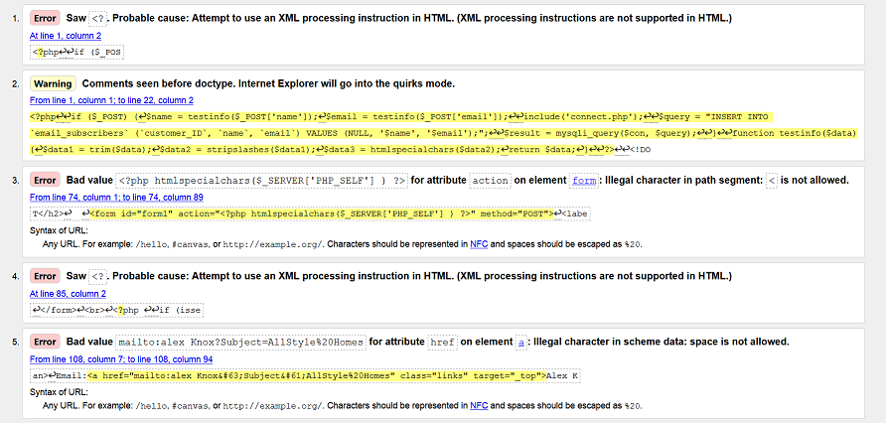

Validator W3.org does not recognize all JavaScript coding; in saying this - above errors does not affect the performance, loading or the websites page. No action taken.

login.php validation

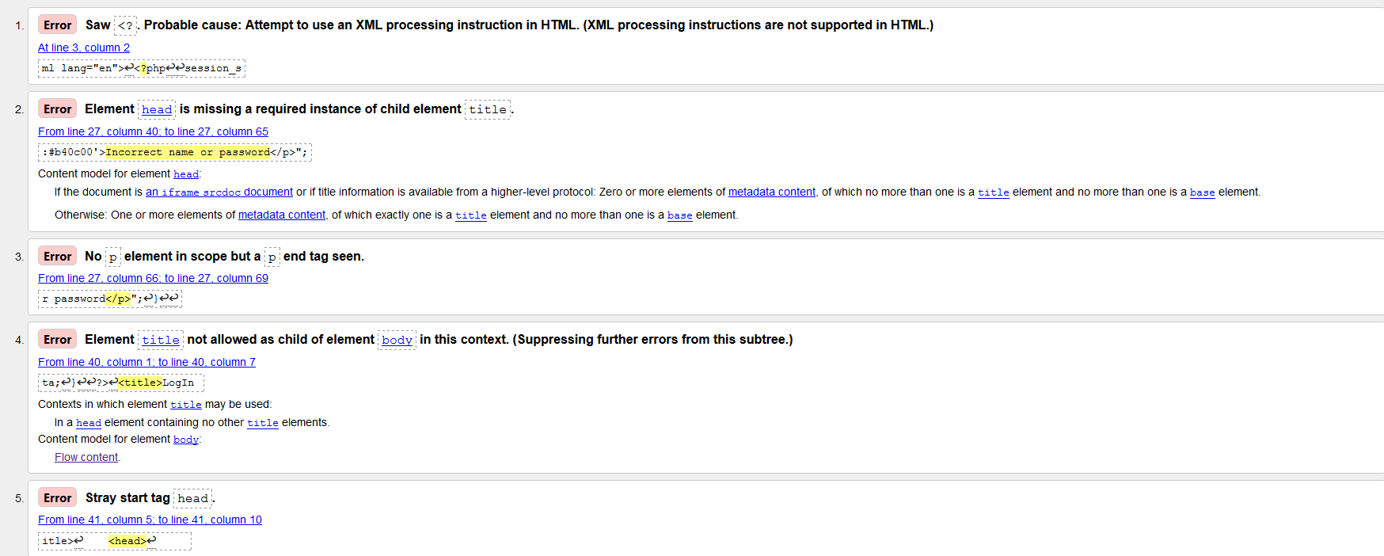

















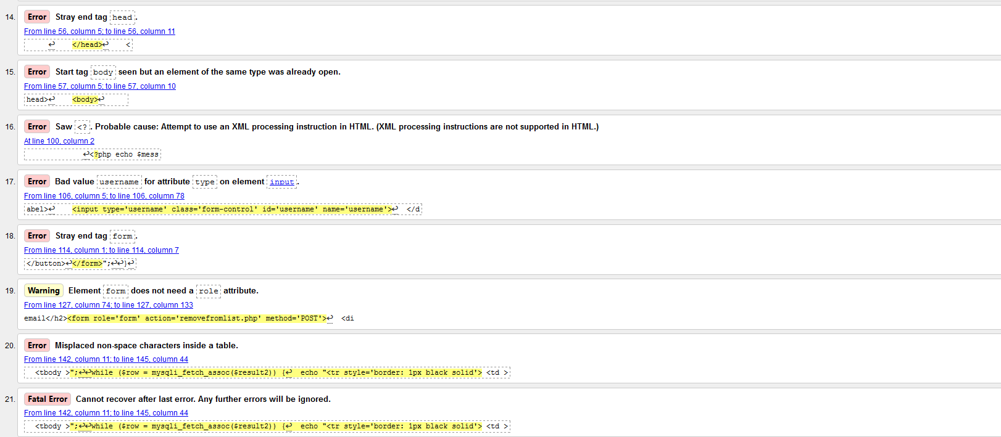

Validator W3.org does not recognize all JavaScript coding; in saying this - above errors does not affect the performance, loading or the websites page. No action taken.

* Re test to ensure - Test the website to ensure it meets accessibility standards including visual impairment.
* Web pages do not contain anything that flashes more than three times in any one second period, this avoiding content that could cause seizures due to photosensitivity.
* Provided text alternatives for non-text content.  
  All images on the site have the alternative text placed into the HTML coding. Every effort was made to ensure that the text is descriptive and informative.
* As well as Alternative text, all images have hover over image titles that appear when the mouse is over the image.
* The navigation system has been kept simple, clean, and a single level menu bar highly visible to the user.
* The website is responsive allowing users to view content on desktop computers as well as mobile devices such as ipads and mobile phones.
* CSS used rather than tables for page layouts.
* If users do not have Adobe PDF reader installed on their system to view the “Terms and conditions” and the sites “Privacy Policy” statement a link is installed inside the footer to download the free version of the software.
* Inserted on each page is an “alert” to notify users their browser is out of date, please upgrade your browser to view this site.
* Load your pages to the development web server
* Test all pages work as required

Figure 31 Screen shots of individual web pages

 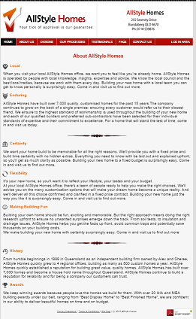 

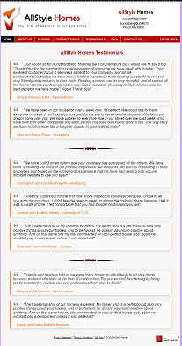 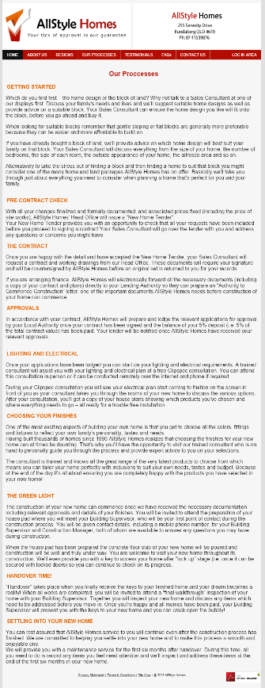 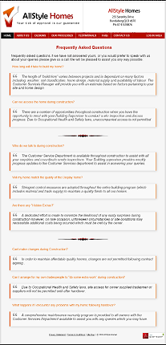

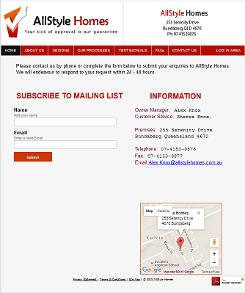 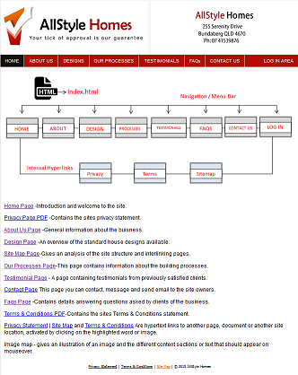

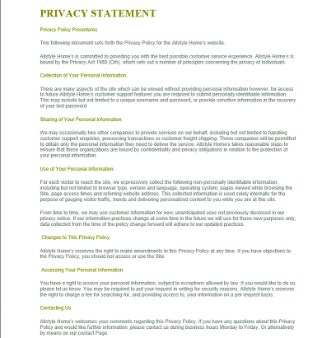 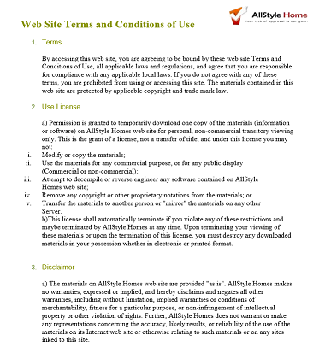

### The test procedures used.

While developing the website I had access and used two separate programs to aid myself in the developing stages of the website. Because I didn’t have access to a physical webserver in class the only option was to use a Virtual software program which was loaded onto a Windows based workstation and used in conjunction with Xampp.

Xampp stands for Cross-Platform (X), Apache (A),MariaDB (M),PHP (P) and Pearl (P), It is a simple, lightweight Apache distribution that makes it extremely easy for developers to create a local web server for testing purposes

While at home I used USB Webserver software which is an easy to use server package that integrates Apache, MySQL and PP, including PHPMyAdmin.

While developing the web pages, areas such as the Navigational bar Left and Right Logo headers, image placement, and content areas often needed modification to the coding, which in conjunction helped with the testing environment while constructing the website pages.

Every webpage was also made to be responsive through media queries and coding, thus ensuring that the website could be viewed on different devices such as computers, ipads and mobile telephones. When all pages were completed they all went through a validation test and corrections and modifications were made where concerned.

The folder structure used.

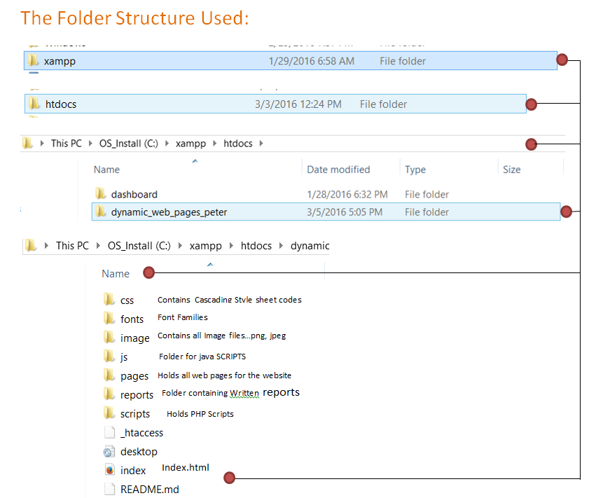

Figure 32 Folder structure used

### Usability Testing

In testing the Allstyle Homes website the below all functioned and passed the test.

* Navigation bar links all work and connected every page.
* All external links work and connect.
* Mouse over functions and click on demand work as well.
* User / Admin Login panel all functional.
* Add / Remove users functional.
* Mailing List functional.
* Dynamic content operational.
* Responsive mode on all devices functional.